15.33: a) The amplitude of the standing wave is 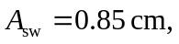the wavelength is twice the distance between adjacent antinodes, and so Eq. (15.28) is

c)

